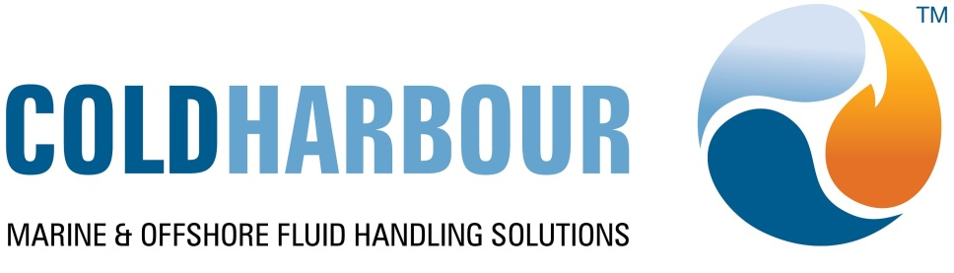

29th January 2016

New R&D and Testing Facilities at Coldharbour Marine

Over £1m has been invested in a new Factory Acceptance and Testing (FAT) facility on Coldharbour Marine’s North Nottinghamshire site. The FAT will be used as for pre-delivery assembly and testing for the company’s Inert Gas Generators, programmable logic control consoles and alarm systems - essential components in Coldharbour’s award winning ballast water treatment system. In support, 200,000 litres of water is stored in an external tank feeding a 50,000 litre internal secondary water system while a 10,500 litre fuel tank allows extending running times, without the need to stop for fuel. A large cooling tower, nicknamed ‘Madonna’s Bra’, completes the external engineering works whose complexity underlines the benefits Coldharbour has derived by siting its new H.Q. on remediated land in the former North Nottinghamshire coalfield.

Inside the FAT, an elevated platform can hold 3 Inert Gas Generators, each separately linked to motor control panels managing combustion airflow and power supplies. A separate control panel manages the testing regime, controlling pumps, valves and cooling systems. All the operating components of an inert gas generator can be assembled and tested in a clean environment before final dispatch to customers. In addition to the vital QA function, having these systems so easily accessed allows Coldharbour Marine to further improve its customer support. Shipyard and customers’ engineering staff will use the facility and associated training rooms where, in a warm, open environment, they can develop an in-depth understanding of system operations and appreciate how on-board installations can be achieved in the minimum possible yard time.

A separate £300,000, 125m² research and development laboratory has been built immediately adjacent to the FAT, where system and component designs can be optimised. The R&D team, overseen by Prof. Bruno Pollet, has a dedicated Development Office and Microbiology Laboratory where an integrated group of scientists, engineers and microbiologists are working to improve the efficacy of the Coldharbour ballast water treatment system, designed to help ship owners and operators protect the marine environment.
.
ENDS
More information from Rosie Featherstone; 07788 592314 or 01332 862073 featherstone.rosie@gmail.com or Andrew Marshall +44(0)1629 888 386

Unveiling the Coldharbour Marine
Madonna’s Bra Cooling Towers



